St George’s  Church of England Primary School | 

Behaviour
Policy

 |  | Issued: | September 2023
 |  | Reviewed: | September 2025
 |  | Next review due: | September 2026

Table of Contents
Table of Contents - 2 -
Introduction - 4 -
Aim - 5 -
Purpose of the Behaviour Policy - 5 -
Reasonable Adaptations - 5 -
Consistency in Approach - 5 -
St. George’s School Rules - 7 -
Visible Consistencies - 7 -
Local Academy Board - 7 -
The Headteacher - 7 -
The Deputy Headteacher - 7 -
The Special Educational Needs Co-Ordinator - 8 -
All Staff - 8 -
Senior Leadership Team - 9 -
Parents and Carers - 9 -
Pupils - 9 -
Managing Daily Behaviour in the Classroom - 10 -
Good to be Green - 10 -
Green Card - 10 -
Gold Card - 10 -
Redirection - 10 -
Stop ‘n’ Think Card - 10 -
Yellow Warning Card - 11 -
Red Card - 11 -
LEAF Line - 12 -
Housepoints - 12 -
Positive Praise Cards (Post-Card) - 12 -
Certificates - 12 -
Gold Award - 12 -
Sharing Work with the Headteacher and Deputy Headteacher - 12 -
Headteacher’s Award - 12 -
Responding to Misbehaviour - 13 -
Practical Steps into Managing Behaviour - 14 -
Sanctions 16
Unacceptable Behaviour 16
Detentions 16
Playtimes and Lunchtimes 17
Sanctions for Reaching Step 4 17
Informing Parents 18
Child-on-Child Abuse 21
Extreme Behaviours 22
Physical Attacks on Adults 22
Suspension 23
Beyond the School Gate 24
Out of School Behaviour 24
Communication of the Policy 24
Appendix 1: School Rules Poster 25
Appendix 2: STAR Learning Expectations 26
Appendix 3: LEAF Line 27
Appendix 4: Housepoints 28
Allocation of Houses 28
Captains 28
Awarding House Points 29
Housepoint Awards 29
Appendix 5: Key Stage 2 - Behaviour Reflection 30
Appendix 6: Key Stage 1 - Behaviour Reflection 32
Appendix 7: Behavioural Principles 33

Introduction
At St. George’s Church of England Primary School, we are inspired by Jesus’ words that ‘I have come that they may have life, and have it to the full.’ (John 10:10). The words of Jesus act as a guide for our Christian school vision where we aim for all at St. George’s to flourish together and enjoy life to the full.
In John, Chapter 10, Jesus describes his purpose on Earth as being the ‘Good Shepherd’ to show us the way. He knows us completely and is therefore able to lead us completely because we are known to him. God wants each person to flourish and so promises to help and guide. We see our purpose as being like the ‘Good Shepherd’ in Psalm 23: proactively seeking to care, support and nurture through a relationship of trust that is lead by example. In turn, we hope, through leading by example, we develop the next generation that can take on that role.
As God can help and guide us, by knowing each one of us, ‘Life to the fullest’ is God’s gift to us. Jesus is there for children and staff to grow physically and spiritually just as he had done (Luke 2:39-40). Our distinct relationship with Jesus, and God, enables us to cultivate our innate self-worth and self-value to have a rich sense of living together through all the ups and downs. Through this close relationship, we nurture and develop the gifts that all in our school have to offer so they have can continue to care for God’s creations.
We live this out through:
- A Christian education
- Serving our local community
- Building each other up

Aim
This policy aims to provide a clear, fair and consistent approach to behaviour based on nurturing principles and restorative practices. This will:
- Foster, nurture and value strong and healthy relationships in recognition of the importance of this as a lifelong skill.
- Use our Christian Values of Faith, Hope and Love to underpin our nurturing and relationship focused approach.
- Provide a safe, respectful, equitable and happy school ethos where learning opportunities are maximised.
- Give staff the tools to enable them to support and equip children with strategies to manage their behaviour and build positive relationships with others.

Purpose of the Behaviour Policy
At St. George’s we develop children’s character and Christian spirit through the ‘St. George’s way’. In order to do this, we define the behaviours and habits that we expect pupils to live out. We want to support our pupils to grow into adults who are polite, respectful, grateful and who put others before themselves – this is how they can show Respect, Empathy, Forgiveness, Honest, Justice and Kindness beyond their St. George’s years. We believe that as pupils practise these behaviours, over time they become habits that positively shape how they feel about themselves and how other people perceive them.

Reasonable Adaptations
While this policy is for all pupils, it will be applied differently in different year groups depending on pupils’ ages and may be applied differently depending on individual pupils’ special educational needs.

Consistency in Approach
To support all learners, we do not have individual class charters or individual class rules. All classes have the same three school rules and our reward systems are consistent across school.
In implementing this policy, we acknowledge the need for consistency. This is:
- Consistent language and consistent response: simple and clear expectations reflected in all conversations about behaviour.
- Consistent follow up: ensuring ‘certainty’ at the classroom and Senior Leadership level.
- Teachers taking responsibility for behaviour interventions, seeking support only where needed.
- Consistent positive reinforcement: routine procedures for reinforcing, encouraging and celebrating.
- Consistent consequences: defined, agreed and applied at the classroom level as well as established structures for more serious behaviours.
- Consistent expectations referencing promoting appropriate behaviour.
- Consistent respect from the adults: even in the face of disrespectful learners.
- Consistent models of emotional control: emotional restraint that is modelled and not just taught, teachers as role models for learning.
- Consistently reinforced rituals and routines for behaviour: in classrooms, in the hall, around school and outside.

St. George’s School Rules
- Follow instructions
- Use kind words
- Keep hands and feet to ourselves

Visible Consistencies

Local Academy Board
- The Local Academy Board is responsible for setting down these general guidelines on standards of behaviour and reviewing their effectiveness.
- The Local Academy Board members support the headteacher in adhering to these guidelines.
- The Headteacher has the day-to-day authority to implement the school's policy on behaviour, but Local Academy Board members may advise the headteacher about particular disciplinary issues. The headteacher must take this into account when making decisions about matters of behaviour.

The Headteacher
- It is the responsibility of the Headteacher to oversee the implementation of the school’s behaviour policy consistently throughout the school.
- Report to the governors, when requested, on the effectiveness of the policy.
- Ensure the health, safety and welfare of all children in the school.
- Setting the standards of behaviour.
- Supporting staff to implement the policy.
- Keep records of all reported serious incidents of behaviour.
- Give a suspension to individual children for serious acts of misbehaviour. For repeated or very serious acts of anti-social behaviour, the headteacher may permanently exclude a child (refer to the Exclusions Policy).

The Deputy Headteacher
- Ensure the effective implementation of the school’s behaviour policy across the school.
- Provide leadership and support to staff in managing student behaviour, including offering guidance on best practices and strategies.
- Regularly monitor and evaluate the effectiveness of the behaviour policy, making adjustments as necessary to improve outcomes.
- Analyse behaviour-related data to identify trends, areas for improvement, and the impact of interventions.
- Organise and deliver training sessions for staff on behaviour management techniques and the specific needs of different student groups.
- Work closely with students to address behavioural issues, providing support and interventions to help them improve.
- Engage with parents and carers to discuss their child’s behaviour, progress, and any support needed at home.
- Liaise with external agencies, such as educational psychologists and social services, to support students with behavioural needs.
- Foster a positive school culture that promotes respect, inclusion, and high expectations for behaviour.
- Report regularly to the headteacher and senior leadership team on the implementation and impact of the behaviour policy.

The Special Educational Needs Co-Ordinator
- Lead the development and regular review of reasonable adaptations to the school’s behaviour policy to ensure it meets the needs of students with special educational needs and disabilities.
- Provide guidance and support to classroom teachers on effective behaviour management strategies tailored to students with special educational needs and disabilities.
- Coordinate and oversee interventions and support plans for students with special educational needs and disabilities to promote positive behaviour.
- Communicate regularly with parents and carers of students with special educational needs and disabilities to discuss behaviour strategies and progress.
- Organise and deliver training for staff on behaviour management techniques and the specific needs of students with special educational needs and disabilities.
- Monitor the behaviour of students with special educational needs and disabilities and report on their progress to senior leadership and other relevant stakeholders.
- Work with external agencies, such as educational psychologists and local authorities, to support students with special educational needs and disabilities.
- Advocate for inclusive practices within the school to ensure that students with special educational needs and disabilities are supported in a positive and respectful manner.

All Staff
- Take time to welcome children at the start of the day and each session.
- Implement the agreed routines and procedures in school to manage behaviour.
- Analyse classroom practice to implement routines and procedures that are required.
- Understand that positive behaviour requires teaching and repeated practice.
- Accompany children to the playground whenever transition from the building to the outside area.
- Be ready to connect with pupils before they correct them.
- Always address children who are struggling to meet expectations using the consistent language from the scripts.
- Always redirect children by referring to the school rules.
- Consistently use ‘Good to be Green’.
- Follow up every time, retain ownership and engage in reflective dialogue with our learners.

Senior Leadership Team
- Take time to welcome learners and their families at the start of the day.
- Be a visible presence around the school, particularly at busy transition times.
- Regularly share good practice.
- Regularly celebrate staff and children whose efforts go above and beyond expectations.
- Encourage use of positive praise.
- Ensure staff training needs are identified and met.
- Use the Child Protection Online Management System (CPOMS) to target and assess interventions.
- Support teachers in managing children with more complex or distressed behaviours.
- Induct new staff so they are clear of the school’s expectations.
- Provide training and support for staff to meet additional needs such as special educational needs, disabilities, or mental health needs which at times may affect pupil’s behaviour.

Parents and Carers
- Parents/carers collaborate with the school so that children receive consistent messages about how to behave at home and at school.
- We expect parents/carers to support their child's learning and co-operate with the school as set out in the home-school agreement.
- We try to build a supportive dialogue between the home and the school, and we inform parents/carers immediately if we have concerns about their child's welfare or behaviour.
- If the school has to use reasonable consequences to help a child follow the school rules and learn well, we expect parents/carers to support the actions of the school.
- Attend all parental consultations during the year.
- Inform school as soon as possible if they have a concern about their child's behaviour, or the behaviour of another child towards their child.

Pupils
- Follow instructions
- Use kind words
- Keep hands and feet to ourselves

Managing Daily Behaviour in the Classroom

Good to be Green
In each classroom there is a Good to be Green chart displayed on the communication wall.
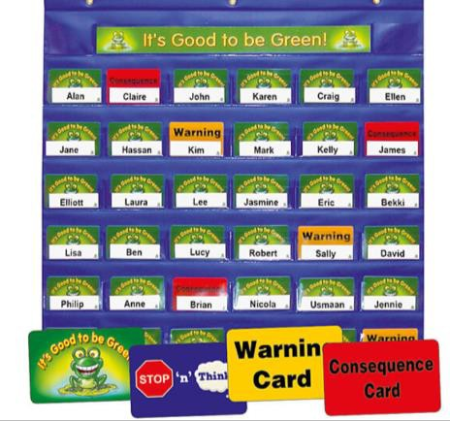

Green Card
Every child starts their day with a green card displayed in their pocket of the class chart. This visibly shows that the school rules are being followed, the High Five values are being lived out and children are using the Leaf line procedure: this is the right thing. If a child remains on green at the end of the day, they are awarded 1 housepoint. At the start of the day and after lunch, all children are on green.

Gold Card
If a child’s behaviour has been impeccable all day, the teacher may award a gold card. Each day, a child from each class will win a gold card and their name be placed on the classroom display. Their name will be entered into the jar in the hall on a Friday for the prize draw during Celebration Worship.

Redirection
If a child is seen to be making poor choices, they will first receive a redirection from their teacher. This will be a non-verbal clue in order to redirect the child to making the right choice and give them a chance to stay on a green card.

Stop ‘n’ Think Card
When a child reaches step 2 of the Practical Steps to Managing Behaviour, a Stop ‘n’ Think card is placed on the child’s desk. This provides a visible consistency to reflect, consider and review their behaviour so they are following the school rules. This should be enough for children to comply, and when the desired behaviours are displayed, the child returns to green. Our approach aims to recognise the desired behaviour quickly, so children return to green at the earliest opportunity.

Yellow Warning Card
If the behaviours in Steps 1 and 2 from the Practical Steps to Managing Behaviour have not been corrected, a Yellow Warning Card is issued for Step 3. This will be placed on the child’s desk. Parents will receive a notification through the Arbor app and will be invited to speak to the class teacher if they wish. Three yellow cards per half-term will result in parents being contacted by our Pastoral Manager. If the child receives two further yellow cards in the same half term then this will result in the child being placed on Stage 1 behaviour plan and a meeting will be held with the parents.

Red Card
When a child reaches step 4 of the Practical Steps to Managing Behaviour, a red consequence card will replace the yellow warning card. This will result in a consequence of a lunchtime detention. Parents will be informed at the end of the day and receive a notification by email. If a child receives three red cards in the same half term then they will be placed on a Stage 1 behaviour plan and a meeting will be held with the parents.

LEAF Line
LEAF is used for lining up and transitioning around school. This is displayed on the classroom’s communication board. Staff demonstrate this by modelling positive behaviours, good manners and speaking to children in a calm and focused way. See Appendix 3: LEAF Line

Housepoints
House Points are awarded one at a time. Any member of staff can award House Points to any child, at any time and for any reason, for their effort or attainment in learning, following the school rules or showing the LEAF expectations.
Further information on Housepoints can be found in Appendix 4: Housepoints.

Positive Praise Cards (Post-Card)
Positive praise cards are sent out on a Thursday by post. These nominate one child per week who has displayed the school values either in their conduct or their work.

Certificates
Each week, there is a certificate for start of the week presented in Celebration Worship once per week. Star of the Week is awarded for a child who has impressed their teacher by either following the school rules, displaying the school values in their conduct or collective worship theme or the effort children have taken in their work. A record of children who have been nominated for a certificate is kept. Parents and carers are welcome to attend these assemblies.

Gold Award
Each week the children from each class who have received a Gold Card that week will be entered into the whole school prize draw. In each weekly Celebration Worship, a winner will be chosen to win a prize.

Sharing Work with the Headteacher and Deputy Headteacher
Where a child goes above and beyond, showing exceptional work, staff send the child with their work to the Headteacher and Deputy Headteacher to receive a special Headteacher’s or Deputy Headteacher’s sticker.

Headteacher’s Award
At the end of half-term, one child per class is nominated by their class teacher for the Headteacher’s award. Each child presents why they have been nominated. Parents and carers are invited to this assembly.

Responding to Misbehaviour
Our aim is to help children to reflect on the consequences of their behaviour choices and where necessary, apply sanctions which encourage them to make the correct choices.
When a member of school staff becomes aware of misbehaviour, they respond predictably, promptly and assertively. This enables pupils to know with certainty that misbehaviour is always addressed.
The purpose of the response is to:
- Deter: sanctions will be issued to deter specific pupils or to deter all pupils.
- Protect: keeping pupils safe is a legal duty. A protective measure, such as removing a pupil from a lesson, may be immediate or after risk assessment.
- Improvement: to support pupils to meet and improve the behaviour expectations this may be through the use of sanctions, reflective conversations or targeted pastoral support.

Practical Steps into Managing Behaviour
Managing and Modifying Behaviours
Step 1 | Redirection | Gentle encouragement or guidance based on your relationship with the child.  For example, non-verbal cues, a reminder of the school rules or clear expectations. | - Proximity  - ‘The look’ (raised eyebrows)  - Eye contact  - Face gesture  - Show me LEAF  - Point to a visual display  - Body language
Step 2 | Reminder  (Stop ‘n’ Think Card) | A reminder of the rules, delivered privately wherever possible. This does not mean taking the child out of the room | At St. George’s, our rule is to .  I noticed you were .  This is your reminder to follow our rule of .
Step 3 | Reflection (Yellow Warning Card) | Verbal caution delivered privately, if possible, making the pupil aware of their behaviour and clearly outlining the consequences if they continue.  Give the pupil a final opportunity to engage. Offer a positive choice to do so and refer to previous examples of good behaviour. | At St. George’s, our rule is to ____.  I noticed you were .  If this behaviour continues, your consequence will be .  Thank you.
Step 4 | Consequence  (Red Card)  This should always be recorded on CPOMS | Use this script, if the pupil still does not engage to follow the correct behaviours. | I noticed you chose to .  You had at least 3 opportunities to make better choices.  You now owe me .
Step 5 | Internal Referral | Work completed in an alternative location in your partner classroom. | This is used if the behaviour persists after a consequence has been issued.  Internal referral is used rarely, fairly and consistently.  The child is sent to the year group  partner classroom to complete their work until the end of the lesson.

Behaviours
Step 1 | Redirection | For example:  - Out of seat  - Rocking on chair  - Calling out  - Not listening or paying attention Pushing, shoving in line  - Running indoors or in the wrong place  - Not working  - Not clearing up  - Distracting other others  - Inappropriate physical contact, e.g. poking, flicking, pulling hair  - Complains or mutters disruptively/persistently  - Talking at an inappropriate time, or asking inappropriate questions to disrupt  - Hides work or resources  - Interferes with other’s property  - Minor deliberate damage (pencils)  - Telling lies to get others into trouble  - Persistent rough play
Step 2 | Reminder  (Stop ‘n’ Think Card) | Where behaviours in Step 1, have persisted and have not been corrected.
Step 3 | Reflection  (Yellow Warning Card) | Two rule reminders have not corrected behaviours in Step 1.
Step 4 | Red Card  This should always be recorded on Arbor | This is for behaviours that have had 3 opportunities to correct and they have not been corrected.
Step 4 | Red Card  This should always be recorded on Arbor | Behaviours that proceed straight to Step 4:  - Bullying  - Harming others - this includes 'hitting back.'  - Swearing  - Spitting  - Name-calling  - Refusing to follow instructions  - Answering back to adults  - Disruption of lessons  - Vandalism to the school or other's property  - Disrespect to school values  - Child on child abuse  This is not an exhaustive list.  A lunchtime detention will be issued as a consequence, where children will have the chance to complete some restorative work around their behaviour.
Step 5 | Internal  Referral | Step 5 is used for behaviours in Step 4 that have persisted.

Sanctions
Teachers have statutory authority to discipline pupils whose behaviour is unacceptable, who break the school rules or who fail to follow a reasonable instruction (Section 91 of the Education and Inspections Act 2006).

Unacceptable Behaviour
The Headteacher will be informed if a child:
- Wilfully inflicts harm on another physically or verbally
- Deliberately endangers someone else
- Wilfully destroys property
The following behaviour will not be tolerated:
- Bullying (see Anti-bullying Policy) - the accepted definition of bullying is one or more children subjecting a child to repeated physical, emotional or verbal abuse over a period of time.'
- Harming others - this includes 'hitting back.'
- Swearing
- Spitting
- Name-calling
- Refusing to follow instructions
- Answering back to adults
- Disruption of lessons
- Vandalism to the school or other's property
- Disrespect to school values
- Child on child abuse
This is not an exhaustive list.

Detentions
Teachers have authority to issue detentions. A detention, such as missing playtime, is a commonly used sanction, often used as a deterrent to future misbehaviour. It is typically a period where the pupil is required to remain under supervision of school staff when their peers have been allowed to go to break or play.
When a detention is issued, it is done so consistently and fairly. This forms part of the sanctions listed above.
Staff will ensure reasonable time is allowed to eat, drink and use the toilet.

Playtimes and Lunchtimes
When not in the classroom, the following consequences will apply:
- Walking with a member of staff
- Supervised time-out
If a child consistently demonstrates inappropriate behaviour, a senior member of staff on duty will be informed. All incidents should be recorded on Arbor.

Sanctions for Reaching Step 4
Sanctions
Behaviours that have not been corrected in Steps 1, 2 or 3, and:  - Bullying  - Harming others - this includes 'hitting back.'  - Swearing  - Spitting  - Name-calling  - Refusing to follow instructions  - Answering back to adults  - Disruption of lessons  - Vandalism to the school or other's property  - Disrespect to school values  - Child on child abuse  This is not an exhaustive list. | All of their lunch time playtime will be missed Appendix 5: Key Stage 2 - Behaviour Reflection or Appendix 6: Key Stage 1 - Behaviour Reflection will be completed.  Depending on the severity of the behaviour, the severity of the sanction will be adjusted to the severity of the behaviour.

Informing Parents
Please note that the cards refer to amount of cards being issued every two weeks.

Informing Parents of Stop ‘n’ Think Cards
Stop ‘n’ Thinks | Action | Outcome
Stop ‘n’ Think card 3 | Parents will be informed through an Arbor notification and will receive a phone call from the Class teacher about their child’s behaviour and that they are close to triggering a Phase Leader meeting.
Stop ‘n’ Think card 4 | Parents will be informed through an Arbor notification and will receive a phone call from the Phase leader about their child’s behaviour.
Stop ‘n’ Think card 5 | Parents are informed on the same day, either in person by telephone. They will also receive a notification through Arbor.  Letter 1 is issued inviting parents to meet with the class teacher and Deputy Headteacher to implement Stage 1 behaviour plan.

Please note that the cards refer to amount of cards being issued per half term.
Informing Parents of Yellow Cards
Yellow cards | Action | Outcome
Yellow Card 1 | Parents will be informed through an Arbor notification and are invited to speak to the class teacher if they wish.
Yellow Card 2 | Parents will be informed through an Arbor notification and are invited to speak to the class teacher if they wish.
Yellow Card 3 | Parents will be informed through an Arbor notification and will receive a phone call from the Phase Leader about their child’s behaviour.
Yellow Card 4 | Parents are informed on the same day, either in person by telephone. They will also receive a notification through Arbor.  Letter 1 is issued inviting parents to meet with the class teacher and Deputy Headteacher to implement Stage 1 behaviour plan. | Child is placed on a Stage 1 behaviour plan.

Informing Parents of Red Cards
Red Cards | Action | Outcome
Red Card 1 | Parents are informed on the same day, either in person  by telephone. They will also receive a notification through Arbor. | The behaviour leading to the red card is logged onto  Arbor.
Red Card 2 | Parents are informed on the same day, either in person  by telephone. They will also receive a notification through Arbor. | The behaviour leading to the red card is logged onto  Arbor.
Red Card 3 | Parents are informed on the same day, either in person by telephone. They will also receive a notification through Arbor.  Letter 1 is issued inviting parents to meet with the class teacher to implement Stage 1 behaviour plan. | The behaviour leading to the red card is logged onto  Arbor.  Stage 1 behaviour plan and target sheets are completed.  Six weeks later the Stage 1 behaviour plan is reviewed.
Whilst Stage 1 is running, further red cards can be issued, which are outlined on the Stage 1 plan. However, Red Card number 4 does not apply until the Stage 1 plan has been completed. The Headteacher’s discretion may be used to move to Red Card 4.This should be enough for the child’s behaviour, with parental support, to be corrected.
Red Card 4 | Parents are informed on the same day, either in person by telephone.  Letter 2 is issued inviting parents to meet with the Deputy Headteacher to implement Stage 2 behaviour plan. | The behaviour leading to the red card is logged onto  Arbor.  Stage 2 behaviour plan and target sheets are completed.  Four weeks later the Stage 2 behaviour plan is reviewed.
Whilst Stage 2 is running, further red cards can be issued, which are outlined on the Stage 2 plan. However, Red Card 5 does not apply until the Stage 2 plan has been completed. The Headteacher’s discretion may be used to move to Red Card 5. This should be enough for the child’s behaviour, with parental support, to be corrected.
Red Card 5 | Parents are informed on the same day, either in person by telephone.  Letter 3 is issued inviting parents to meet with the Headteacher to implement Stage 3 behaviour plan. | The behaviour leading to the red card is logged onto Arbor  Stage 3 behaviour plan and target sheets are completed.  Four weeks later the Stage 3 behaviour plan is reviewed.

Child-on-Child Abuse
Sexual violence and sexual harassment can occur between two children of any age and sex. It can occur through a group of children sexually assaulting or sexually harassing a single child or group of children. Sexual violence and sexual harassment exist on a continuum and may overlap; they can occur online and face to face (both physically and verbally) and are never acceptable.
At St. George’s all staff working with children are advised to maintain an attitude of ‘it could happen here’. Addressing inappropriate behaviour (even if it appears to be relatively innocuous) can be an important intervention that helps prevent problematic, abusive and/or violent behaviour in the future.
Children who are victims of sexual violence and sexual harassment wherever it happens, will likely find the experience stressful and distressing. This will, in all likelihood, adversely affect their educational attainment and will be exacerbated if the alleged perpetrator(s) attends the same school or college.
Whilst any report of sexual violence or sexual harassment should be taken seriously, staff should be aware it is more likely that girls will be the victims of sexual violence and sexual harassment and more likely it will be perpetrated by boys. But it is essential that all victims are reassured that they are being taken seriously and that they will be supported and kept safe. A victim should never be given the impression that they are creating a problem by reporting sexual violence or sexual harassment. Nor should a victim ever be made to feel ashamed for making a report.
- In order for all pupils to experience life in all its fullness, reports of child on child sexual violence and sexual harassment will be reported immediately to the Designated Safeguarding Lead, who will investigate and deal with it with the upmost importance. Therefore, child on child sexual violence and sexual harassment will be categorised as a bullying incident
- If needed, advice will be sought from the Children's Advice and Support Service and, on advice, be escalated to Birmingham Children's Trust and the Police to investigate further.
- See the Child on Child Abuse Policy and Procedural Guidance for a complete overview.

Extreme Behaviours
Some children exhibit particular behaviours based on early childhood experiences and family circumstances. As a school, we recognise that their behaviour is their way of communicating their emotions. We also understand that for many children they need to feel a level of safety before they exhibit extreme behaviours. Where possible, we use our most skilful staff to build relationships with each individual child. These children will have bespoke 'Positive Behaviour Management Plan'.
When dealing with an episode of extreme behaviour, a child may need to be held if they or another person is unsafe. This will only be used as a last resort. Staff in school have been trained. The school will record all serious behaviour incidents on CPOMS and any holds in the bound book which is locked in the filing cabinet in the headteacher’s office.

Physical Attacks on Adults
At St. George’s, we take incidents of violence toward staff very seriously. We also understand that staff are the adults in the situation and can use a 'common sense' approach to keep themselves and the child safe to manage the situation effectively. Staff can use 'reasonable measures' to protect themselves in accordance with our Physical Intervention Policy and should call for support if needed.
All staff should report incidents directly to the headteacher or member of senior leadership team and they should be recorded on CPOMS. We appreciate these incidents can cause distress for the adults involved. Therefore, all staff are entitled to take some time away from the classroom to recover their composure. In extreme cases, the member of staff may be allowed to go home by a member of senior leadership team.
While incidences of violence towards staff are wholly unacceptable, we must remember that we are a nurturing school that values each child under our care. It is important for us as adults to reflect on the situation and learn from our actions. Children who attack adults may do this for several reasons, but we still need to show compassion and care for the child.

Suspension
Suspensions will occur following extreme incidents at the discretion of the headteacher. A suspension will be enforced under these conditions:
- The child needs time to reflect on their behaviour
- To give the school time to create a plan which will support the child better
- The child being at home will have a positive impact on future behaviour
We understand that throughout this process, it is imperative that we explain what is happening and why it is happening to parents/carers and arrange meetings to discuss.
Exclusion is an extreme step and will only be taken in cases where:
- Long-term misbehaviour where the child is not responding to the strategies and the safety and learning of others is being seriously hindered.
- The risk to staff and other children is too high.
- The impact on staff, children and learning is too high.
A permanent exclusion will be the last resort and the school will endeavour to work with the family to complete a managed move to a more suitable setting. In all instances, what is best for the child will be at the heart of all decisions. A Permanent Exclusion Register will be kept by the Behaviour Lead to monitor exclusions.

Beyond the School Gate
Teachers can discipline pupils at any time the pupil is in school or elsewhere under the charge of a teacher, including on school visits. Teachers can also discipline pupils for misbehaviour outside school (Section 89 of the Education and Inspections Act, 2006).
While this behaviour policy refers mainly to the behaviours of pupils within school premises, the school reserves the right to discipline beyond the school gate.
Our policy covers any inappropriate behaviour when children are:
- taking part in any school organised or school-related activity
- travelling to or from school
- wearing school uniform
- in some way identifiable as a pupil from our school
- poses a threat to another pupil or member of the public
- could adversely affect the reputation of the school
In the incidences above, the headteacher may notify the police of any actions taken against a pupil. If the behaviour is criminal or causes a threat to a public member, the police will always be informed.

Out of School Behaviour
The school is committed to ensuring our pupils act as positive ambassadors for us. Taking the above into account, we expect the following:
- Good behaviour to and from school, on educational visits or during learning opportunities in other schools
- Positive behaviour which does not threaten the health, safety or welfare of our pupils, staff, volunteers or members of the public.
- Reassurance to members of the public about school care and control over pupils in order to protect the reputation of the school.
- Protection for individual staff and pupils from harmful conduct by pupils of the school when not on the school site.
- The same behaviour expectations for pupils on the school premises apply to off-site behaviour.

Communication of the Policy
This policy will be communicated to all members of the community once per year in writing to parents, staff and pupils. We do this because it is an important way of building and maintaining the school’s culture. It makes behaviour expectations transparent to all pupils, parents, and staff members, and provides reassurance that expectations of, and responses to, behaviour are consistent, fair, proportionate, and predictable.

Appendix 1: School Rules Poster
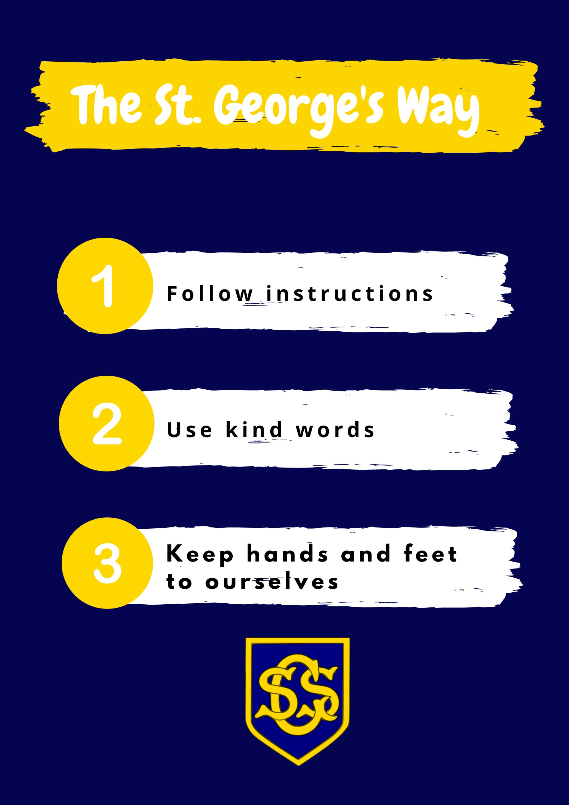

Appendix 2: STAR Learning Expectations
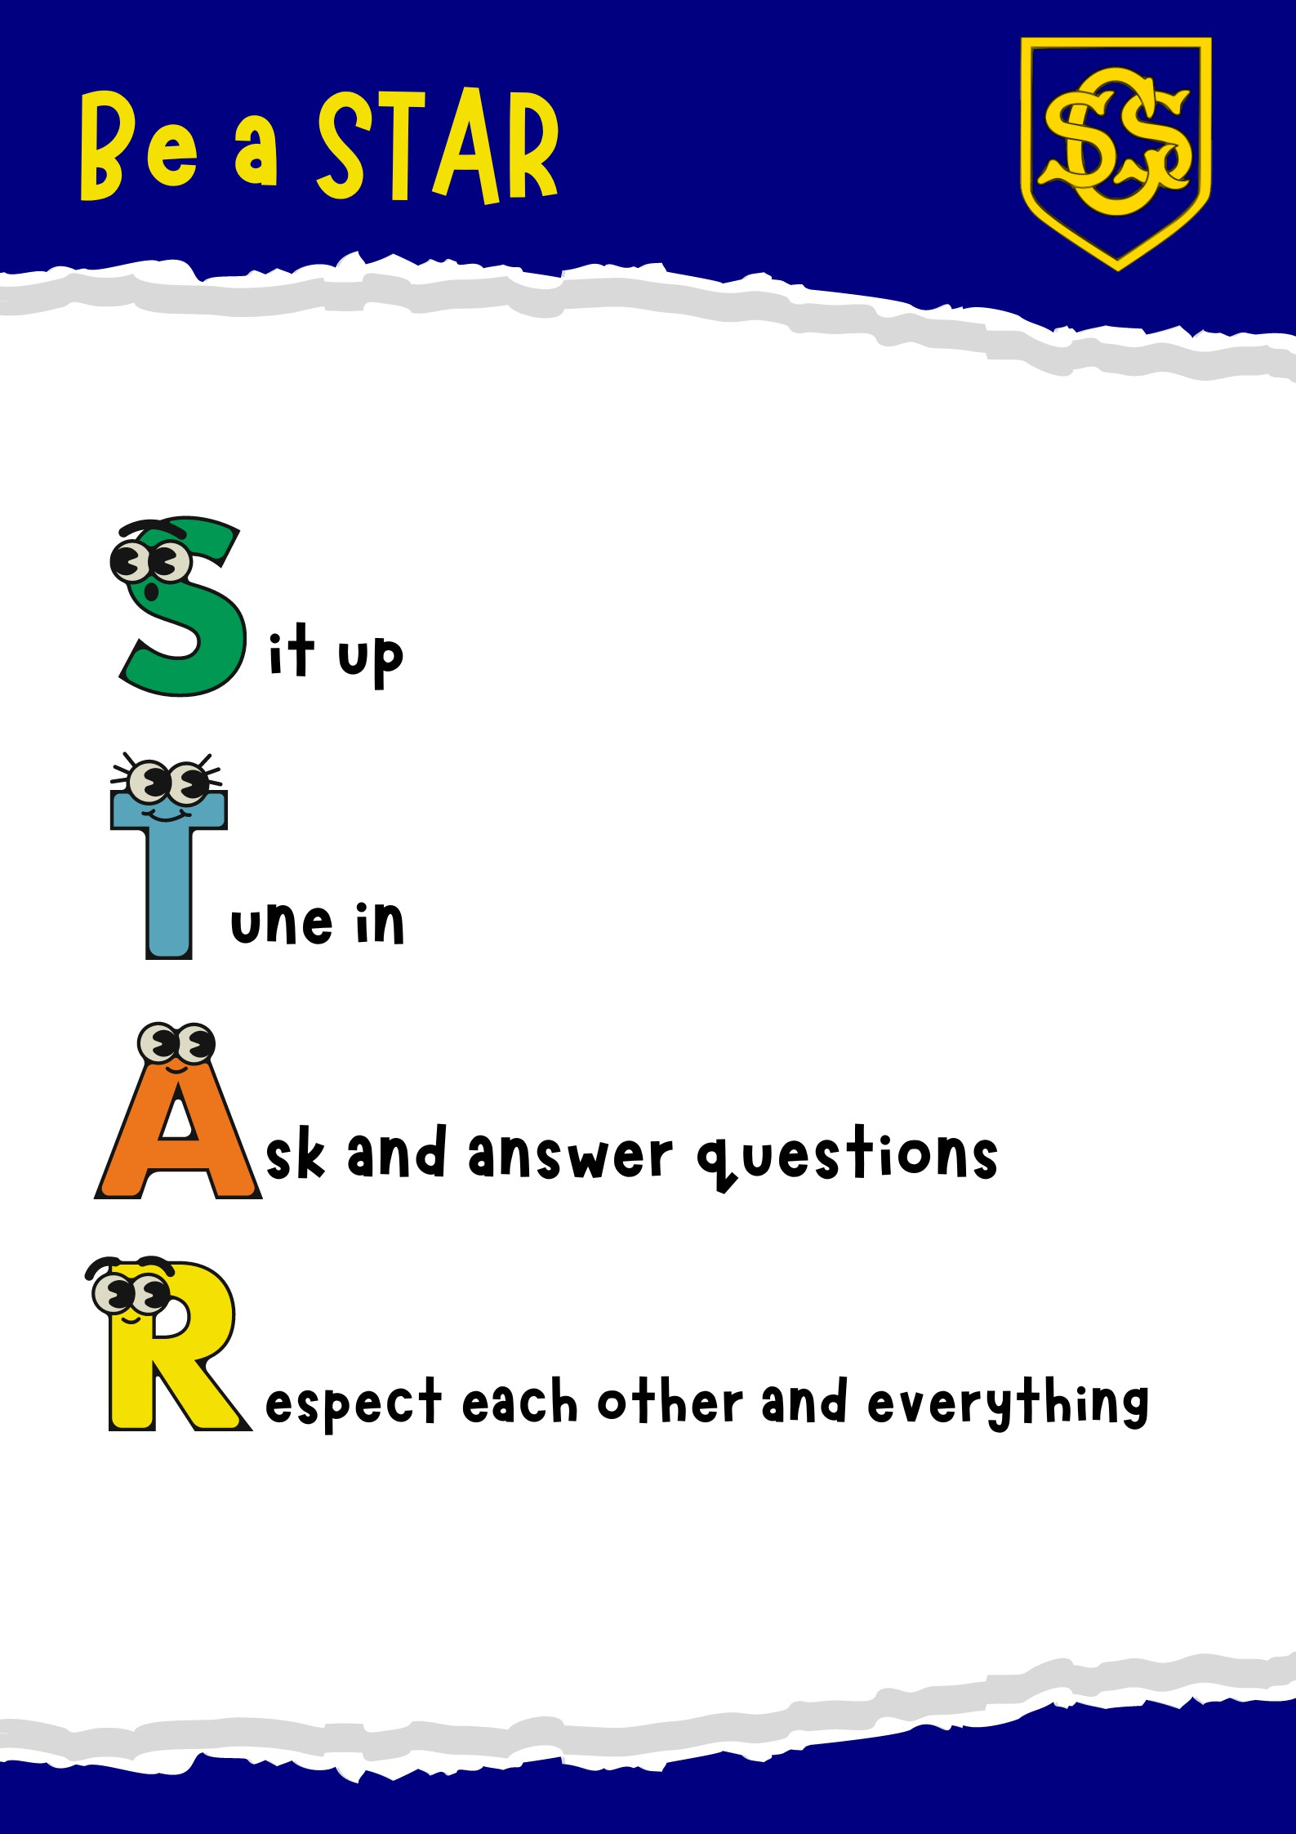

Appendix 3: LEAF Line
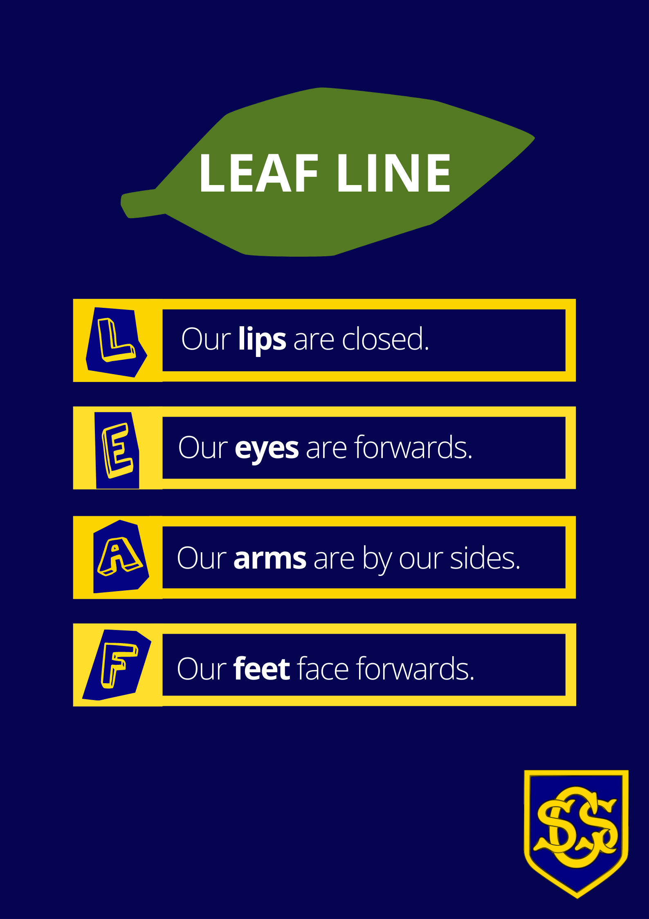

Appendix 4: Housepoints
The House system has been an effective way of promoting team spirit and encouraging children to aim high and take pride in achieving House Points. As children from every class are in every House, the system is an effective way to mix year groups and encourage older children to take care of younger ones and set an example for them.
Houses
- St. Francis of Assisi
- St. Catherine of Sienna
- St. Josephine
- St. Michael

Allocation of Houses
Children are allocated to a house when they start Reception or when they join the school at a later stage. Where possible, children of the same family are allocated to the same house whilst ensuring that the number of children is fairly balanced.
Children’s Houses are recorded on Arbor.
All members of staff except the Headteacher are allocated to one of the Houses. Staff members of Houses are expected to support House Captains. House Assemblies will be led by members of staff allocated to each House, supported by House Captains. Staff are asked to join in competitions organised for the Houses.

Captains
There are two Captains for each House. At the beginning of the new year, Year 6 children will be given the opportunity to nominate themselves in writing as House Captains. The Senior Leadership Team (headteacher and deputy headteacher) will then interview all the children who have nominated themselves. They will decide on the Captains after consultation with class teachers.
The Captains will wear badges to show their position in the school. Captains will be expected to:
- Bring their House into assembly quietly and sensibly

- Sit at the front of their house at assembly and encourage good behaviour from members of their House
- Be an example of exemplary behaviour and attitude
- Help in the lunchroom on a rota basis (at least one Captain on duty each day)
- Organise a rota of helpers to help in the lunchroom – assist with opening items in packed lunches, putting dirty crockery and cutlery in the correct places, checking that litter is not thrown on the floor etc.
- Organise House competitions
- Contribute to House Assemblies
- Propose ideas that will improve the House System
- Represent the pupils on school occasions by greeting visitors, escorting them, giving short speeches of welcome or thanks etc.
- Attend meetings with the Headteacher
Captains whose behaviour or attitude is not a good example to others will be asked to stand down from the position.

Awarding House Points
House Points are awarded one at a time. Any member of staff can award House Points to any child, at any time and for any reason, for their effort or attainment in learning, following the school rules, or showing the LEAF and STAR expectations.
The Headteacher and Deputy Headteacher can hand out Golden Housepoints to any pupil for special achievements, being especially helpful, going above and beyond or for exemplary positive behaviour. The Gold Housepoints are a Headteacher or Assistant Headteacher’s sticker and this is placed on their housepoint reward chart. Golden Housepoints are worth 10 housepoints.

Housepoint Awards
Weekly Award: At the end of each assembly, the weekly winners will be announced. Members of the winning house will stand for applause and congratulations.
Interim Awards: These will be given when the House reaches the following amount of points during a term:
Termly Awards: The House who has earned the most points over a term will be given the choice from the following rewards. The Captains will choose the reward and the staff members of the House will supervise the chosen activity. The choice of different rewards given to the children will be dependent upon staffing availability, weather and financial constraints.
Annual Award: The name of the House and House Captains will be inscribed on the St. George’s Shield to be displayed in the school Reception Area.

Appendix 5: Key Stage 2 - Behaviour Reflection
Name |  | Date
 |  | Class

You are missing your playtime today because you have not followed the school rules.
Instructions
- Read the question.
- Write your answer.
- Re-read your answer to check for spellings and punctuation.
Your handwriting should be the best that you can do.
Write the three school rules:
1.
2.
3.

Write the six school values:
1. | 4.
2. | 5.
3. | 6.

Which school rule have you not followed?

Describe your behaviour

Describe how your behaviour affected other people?

What will you do next time?

What rule are you going to work on?

Appendix 6: Key Stage 1 - Behaviour Reflection
Name |  | Date
 |  | Class

Write the three school rules:
1.
2.
3.

Which school rule have you not followed?

What have you done?

What will you do next time?

What rule are you going to work on?

Appendix 7
Statement of Behavioural Principles
Rationale and Purpose
The LAB of St George’s Church of England Primary School have set out our statement of behavioural principles founded on the belief in the intrinsic value and potential of every child and their right to have their needs met regardless of their background. Everything within this statement is rooted in and underpinned by the school’s core Christian values of Love, Trust, Thankfulness, Respect, Forgiveness and Community.
This Statement has been drawn up in accordance with section 88(2) of the Education and Inspections Act 2006 and DfE guidance (Behaviour and Discipline in Schools: Guidance for Governing Bodies). The purpose of this statement is to provide guidance for the Headteacher and staff in drawing up the Behaviour Policy so that it reflects the shared aspirations and beliefs of governors, staff and parents for the children in the school, as well as taking full account of law and guidance on behaviour matters.
Core Principles
Right to feel safe and respected at all times:
All pupils, staff, parents and visitors have the right to feel safe at all times whilst in school and should always treat each other with respect, using the principles of restorative justice.
High standards of behaviour:
The governors believe that high standards of behaviour are essential for a successful school, the best outcomes for our children and for achieving the school’s vision. It is expected that all adults – staff, volunteers and governors – will set the excellent examples to the children at all times.
Inclusivity and equality:
St George’s is an inclusive school where all members of the school community should be free from discrimination, harassment, victimisation and any other conduct that is prohibited by or under the Equality Act 2010.
Rewards and sanctions:
The Behaviour Policy must make it clear how and when rewards and sanctions, which include exclusions, will be applied.
Working with parents and others:
The Behaviour Policy will make it clear how the school will work with all parents regarding their child’s behaviour. It will also set out the criteria the school will use to determine when a multi-agency assessment will be considered for pupils who display continuous disruptive behaviour.
The use of reasonable force or other physical contact:
The Behaviour Policy should clearly set out the circumstances where staff and others with authority may use reasonable force or other physical contact to control inappropriate behaviour, remove disruptive pupils from learning environments or prevent pupils from leaving learning environments or school premises. The Behaviour Policy must include a definition of ‘reasonable force’ and must explain how and under what circumstances pupils may be restrained. It must also pay due regard to pupil’s mental and emotional wellbeing.
Power to screen and search pupils: The Behaviour Policy should clearly explain to staff and others with authority their powers to screen and search pupils for items that are prohibited or banned from school.
The power to discipline beyond the school gate: The Behaviour Policy should set out the school’s response to any non-criminal bad behaviour or bullying that occurs anywhere away from the school premises and which is witnessed by a member of staff or is reported to the school.
Pastoral care for school staff accused of misconduct: The Behaviour Policy should set out the disciplinary action that will be taken against pupils who are found to have made malicious accusations against school staff. Governors expect the Headteacher to draw on the advice in ‘Dealing with Allegations of Abuse against Teachers’ and other staff guidance documents when setting out the pastoral support that school staff should expect to receive if they are accused of misusing their powers. Staff so accused should not be automatically suspended pending an investigation.
This statement of principles should be read in conjunction with other key safeguarding and wellbeing policies as listed in the Behaviour Policy.

